October 2021

Stories of Hope, Healing and Renewal After Disaster
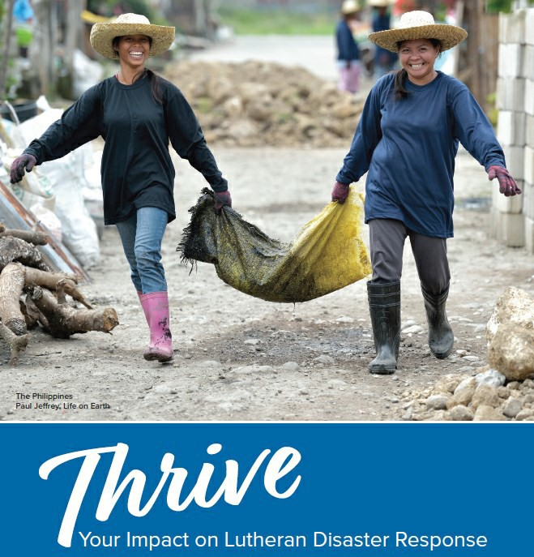
“Thrive: Your Impact on Lutheran Disaster Response” is a brand-new publication that shares stories about people around the world accompanied by Lutheran Disaster Response. Through companion churches, ELCA synods and ecumenical partners, Lutheran Disaster Response shares God’s hope, healing and renewal with people whose lives have been disrupted by disasters. From sponsoring asylum-seekers in Wisconsin to promoting disaster risk reduction in Nepal, the stories told here represent just a fraction of Lutheran Disaster Response’s work. As we respond to Hurricane Ida, the earthquake in Haiti and the crisis in Afghanistan, “Thrive” serves as a reminder that Lutheran Disaster Response remains in communities long after the headlines change.

Read the full report here.

News Around the World

Mission Personnel

As Afghan evacuees arrive in the United States, Lutheran Immigration and Refugee Service (LIRS) is resettling Afghan families. In addition to supplementing the work of LIRS, Lutheran Disaster Response is reaching out to synods, congregations and affiliates that are welcoming Afghan refugees. In Afghanistan, the increase in conflict is forcing people to flee their homes. Community World Service Asia (CWSA) is assisting internally displaced Afghan families through food security and cash assistance. Lutheran Disaster Response contributed to ACT Alliance’s Rapid Response Fund, which is funding CWSA’s work in Afghanistan.

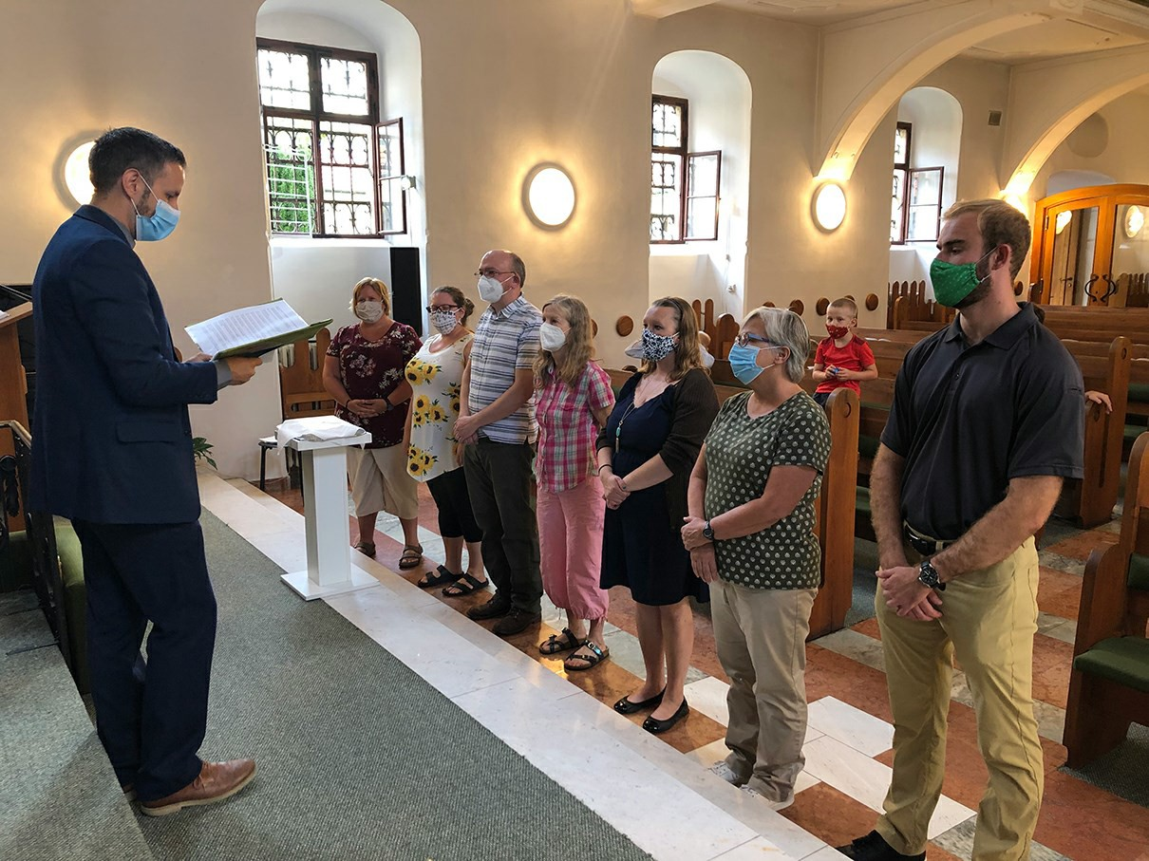

Since 1994, the Evangelical Lutheran Church of the Augsburg Confession in Slovakia and the Evangelical Lutheran Church in America have cooperated to welcome volunteer teachers to Central Europe. The program welcomes 12-20 new and returning volunteer teachers to serve in Lutheran schools in several towns and cities. Unfortunately, because of the COVID-19 pandemic’s impact on borders and travel, the ELCA was unable to send any new volunteer teachers in the 2020-2021 academic year. However, this August we were able to welcome new volunteer teachers, who joined those about to return. At the end of their in-country orientation in Bratislava, Slovakia, the teachers were blessed for their year of ministry by the Rev. Kyle Svennungsen, pastor of Bratislava International Church.

Get Involved
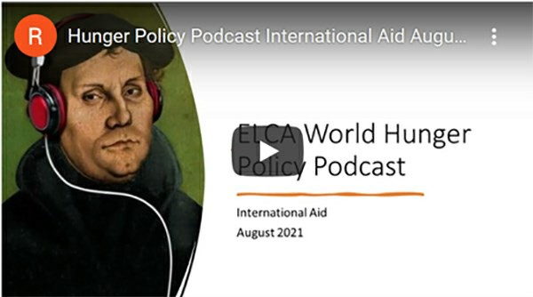

Learn more about international aid with the most recent episode of ELCA World Hunger’s Hunger Policy Podcast. Patricia Kisare, international policy adviser for the ELCA, and Kaari Reierson, ELCA associate for Corporate Social Responsibility, join Ryan Cumming, program director for hunger education. Together, they break down some of the myths and realities of U.S. aid and the church’s witness when it comes to this part of the federal budget. Patricia and Kaari also share a new resource to help congregations learn more about international aid. Find the episode and more information here. Get to know the new International Women Leaders scholarship recipients at a virtual meet and greet! The event will take place on Thursday, Nov. 4, at 7 p.m. Central time. Join us here via Zoom to meet 10 new students from partner churches around the world. Email Rahel Williams at Rahel.Mwitula-Williams@elca.org with any questions.
SUBSCRIBE
GIVE
CONTACT

FOLLOW US

Share “ELCA Global Links”
Please forward “ELCA Global Links,” in whole or in part, for use in publications, websites or blogs.

You received this email because you provided the Evangelical Lutheran Church in America with your email address.

© Evangelical Lutheran Church in America, 8765 W. Higgins Rd., Chicago, IL 60631-4101 800-638-3522

ELCA Global Mission | Privacy | Unsubscribe | Terms of Use Contact Us | Donate | Subscribe

